Write a Custom Local Authenticator

How to configure

Please refer to the documentation from here to write a custom local authenticator for Identity Server.

Troubleshooting the Sample Authenticator

- SampleAuthenticator doesn’t show up in the actual login page.

Solution:
During Configuring the Application to use the SampleAuthenticator in the Login Flow, make sure to remove all the other authentication options and add only the SampleAuthenticator.
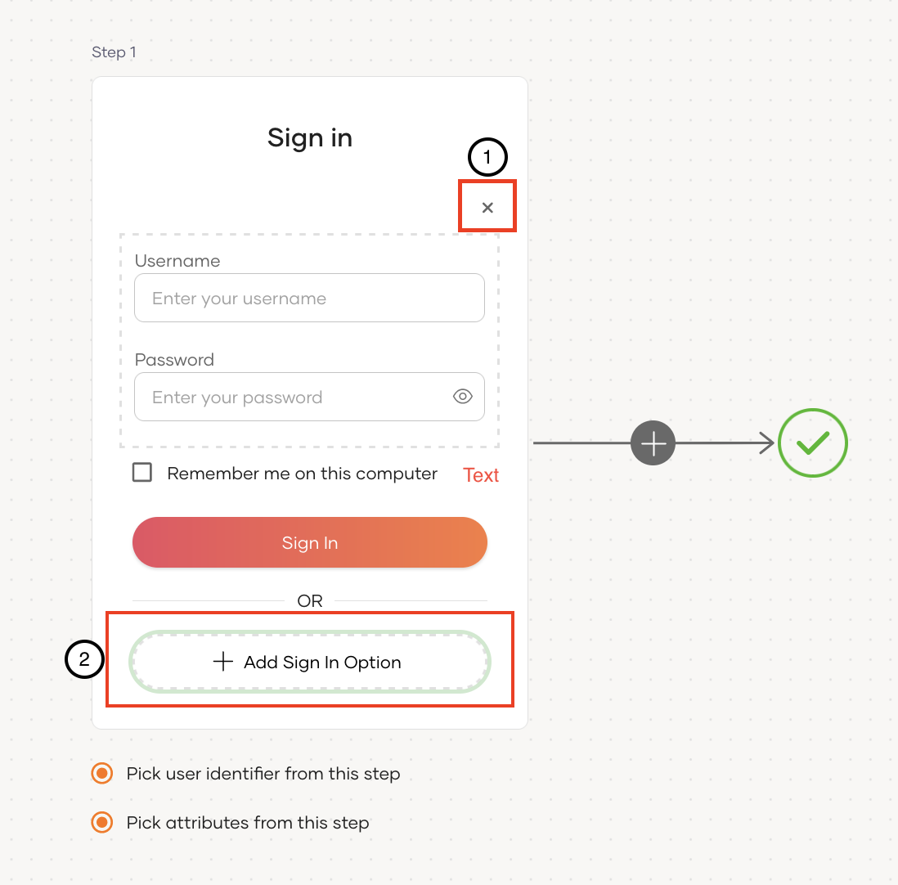
1. Remove the existing BasicAuthenticator
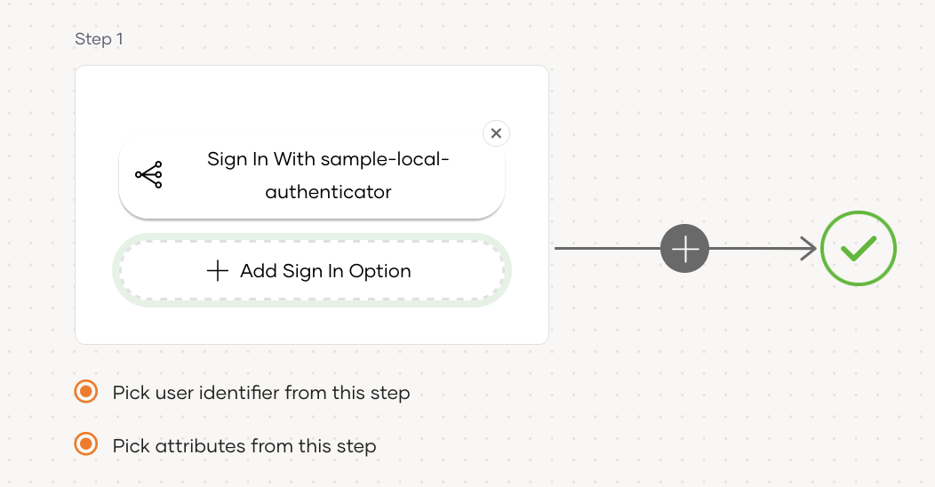
2. Add the new SampleAuthenticator

- When the correct username and password are added, authentication fails.

Solution:
Add the mobile number configured as the username and the usual password for the account.

